Network Penetration Testing Report

Target System | Metasploitable2
Tested By | Dharmendra Kumar
Date | 30 March 2026
Company/Organization | Terra System Labs Pvt Ltd

About this Document
This document provides an overview of the penetration testing activities performed on the Metasploitable2 system using the Metasploit Framework in a controlled lab environment. The purpose of this report is to document the complete testing process, including the steps taken to identify vulnerabilities and successfully exploit them.
The report includes detailed explanations of the methodology followed during the assessment, along with practical demonstrations of exploitation using Metasploit modules. Wherever applicable, commands, outputs, and supporting evidence are included to clearly show how access to the system was achieved.
A visual and step-by-step approach has been used to make the report easy to understand, especially for learning and demonstration purposes. This includes descriptions of vulnerabilities, exploitation techniques, and the impact of successful attacks.
This report is intended to be clear, structured, and reproducible. All steps are documented in such a way that another individual can follow the same process and achieve similar results in the same lab environment.

Table of Contents
1.0 Network Penetration Testing Report…………….………...……………........................................................4
1.1 Introduction ......................................................................................................................................4
1.2 Objective ...........................................................................................................................................4
1.3 Requirements.....................................................................................................................................4
2.0 Report – High-Level Summary ...........................................................................................................5
2.1 Report - Recommendations ...............................................................................................................5
3.0 Report – Methodologies ...................................................................................................................5
3.1 Report – Information Gathering.........................................................................................................6
3.2 Report – Service Enumeration ...........................................................................................................6
3.3 Report – Penetration..........................................................................................................................7
3.4 Report – House Cleaning.................................................................................................................14
4.0 Conclusion………………........................................................................................................................14

1.0 Network Penetration Testing Report
1.1 Introduction
This report presents the results of a network penetration test conducted on the Metasploitable2 system in a controlled lab environment. The objective of this assessment was to identify security vulnerabilities and demonstrate how they can be exploited using real-world attack techniques.
The testing was performed using a structured methodology, including reconnaissance, scanning, enumeration, exploitation, and post-exploitation. The Metasploit Framework was primarily used to exploit identified vulnerabilities and gain unauthorized access.
All activities were conducted in an isolated environment for educational and security research purposes.
1.2 Objective
The objective of this assessment is to perform an internal penetration test against the target system in order to identify and exploit security vulnerabilities and evaluate its overall security posture. The assessment aims to simulate real-world attack scenarios by identifying open ports and running services, analyzing them for potential vulnerabilities, and exploiting these weaknesses using the Metasploit Framework. Furthermore, the test focuses on gaining unauthorized access to the system, achieving privilege escalation where possible, and demonstrating the impact of these vulnerabilities. All findings are documented in detail along with appropriate recommendations to improve the security of the system.

1.3 Requirements
This penetration testing report is prepared to provide a complete and clear overview of the assessment. It includes a high-level summary along with non-technical recommendations to help understand the overall security posture of the system. The report also covers a detailed methodology, explaining each step taken during the testing process.
All identified vulnerabilities are documented with proper explanations, along with supporting evidence such as screenshots, step-by-step walkthroughs, sample commands or code, and proof files wherever applicable. Any additional relevant information that helps in better understanding the assessment and its outcomes has also been included in the report.

2.0 Report – High-Level Summary
Dharmendra Kumar was tasked with performing an internal penetration test on the Metasploitable2 system within a controlled lab environment. An internal penetration test simulates an attack from within the network to identify security weaknesses in systems and services.
The primary focus of this assessment was to simulate real-world attack scenarios by identifying active systems, enumerating services, and exploiting vulnerabilities using the Metasploit Framework. The objective was to evaluate the security posture of the target system, identify misconfigurations and vulnerabilities, and demonstrate how an attacker could gain unauthorized access.
During the assessment, several critical vulnerabilities were identified, mainly due to outdated software, insecure configurations, and intentionally vulnerable services. These weaknesses allowed the tester to successfully exploit multiple services and gain access to the system. In several cases, administrative (root-level) access was achieved, highlighting the severity of the vulnerabilities present.
For example, the tester was able to gain a low-privilege shell through a vulnerable service and further escalate privileges using Metasploit techniques, ultimately achieving full system control. These findings demonstrate that the system is highly vulnerable to real-world attacks and requires immediate security improvements.

2.1 Report – Recommendations
It is strongly recommended to address the vulnerabilities identified during this penetration test to prevent potential exploitation by attackers. This includes applying the latest security patches, updating outdated software, and fixing insecure configurations.
Regular patch management should be implemented to ensure that systems remain up to date and protected against newly discovered vulnerabilities. In addition, unnecessary services should be disabled, and proper security controls such as firewalls and monitoring mechanisms should be put in place to strengthen the overall security posture.

3.0 Report – Methodologies
A structured and widely accepted penetration testing methodology was followed during this assessment to evaluate the security of the target system. The approach was designed to simulate real-world attack scenarios and identify potential weaknesses in the system.
The testing process included multiple phases such as information gathering, service enumeration, vulnerability identification, exploitation using the Metasploit Framework, and post-exploitation activities. This methodology ensured a systematic and effective assessment of the system’s security, allowing the identification and successful exploitation of vulnerabilities.

3.1 Report – Information Gathering
The information gathering phase is the first step of the penetration testing process, where the target system and its scope are identified. During this assessment, the focus was on analyzing the Metasploitable2 machine within the lab environment.
The target system was identified with the following IP address:
Lab Network: 192.168.1.10
This phase helped in understanding the target and preparing for further scanning and enumeration activities.
3.2 Report – Service Enumeration
The service enumeration phase involves identifying active services running on the target system. This step is important as it provides detailed information about open ports, running applications, and potential entry points for exploitation.
Tools like Nmap were used to discover open ports and the services associated with them. By analyzing this information, it becomes easier to identify possible vulnerabilities and plan the next steps of the penetration test. This phase plays a key role in understanding the attack surface of the system before moving to exploitation.
Server IP Address
192.168.1.10

Ports Open | Service/Version
21 | FTP vsftpd 2.3.4
22 | SSH OpenSSH 4.7p1
23 | TELNET Linux telnetd
25 | SMTP Postfix smtpd
53 | DNS ISC BIND 9.4.2
80 | HTTP Apache httpd 2.2.8
111 | Rpcbind (RPC #100000
139 | netbios-ssn Samba smbd 3.X - 4.X
445 | netbios-ssn Samba smbd 3.0.20-Debian
512 | Exec netkit-rsh rexecd
513 | login
514 | Java-rmi
1099 | bindshell
1524 | tcpwrapped
2049 | nfs
2121 | ftp ProFTPD 1.3.1
3306 | Mysql MySQL 5.0.51a-3ubuntu5
3632 | Distccd distccd v1 ((GNU) 4.2.4
5432 | Postgresql PostgreSQL DB 8.3.0 - 8.3.7
5900 | Vnc VNC (protocol 3.3)
6000 | X11
6667 | irc
6697 | irc
8009 | ajp13
8180 | http
8787 | drb
37281 | status
46021 | nlockmgr
54561,60082 | Mountd, java-rmi
3.3 Report – Penetration
The penetration phase of the assessment focused on actively exploiting identified vulnerabilities to gain unauthorized access to the target system. Using the information gathered during earlier phases, various services were tested for known weaknesses, primarily using the Metasploit Framework.
During this assessment, successful access was gained to the target system (Metasploitable2) due to multiple vulnerable and outdated services.
Vulnerability Exploited: vsFTPd Backdoor (FTP Service)
Target System: 192.168.1.10
Vulnerability Explanation:
The FTP service running on the target system was found to be vulnerable to a known backdoor vulnerability in vsFTPd version 2.3.4. This vulnerability allows an attacker to gain unauthorized command shell access by sending a specially crafted request to the service.
By leveraging this vulnerability through the Metasploit Framework, a remote shell was successfully obtained on the target system.
Privilege Escalation:
In this lab environment, the exploited service provided direct shell access. Further enumeration allowed access to sensitive system information, demonstrating a high level of compromise.
Severity: Critical
Information Gathering:
A full Nmap scan was performed to identify all open ports and services on the target system. The results revealed multiple vulnerable services, which were further analyzed and exploited during this phase.
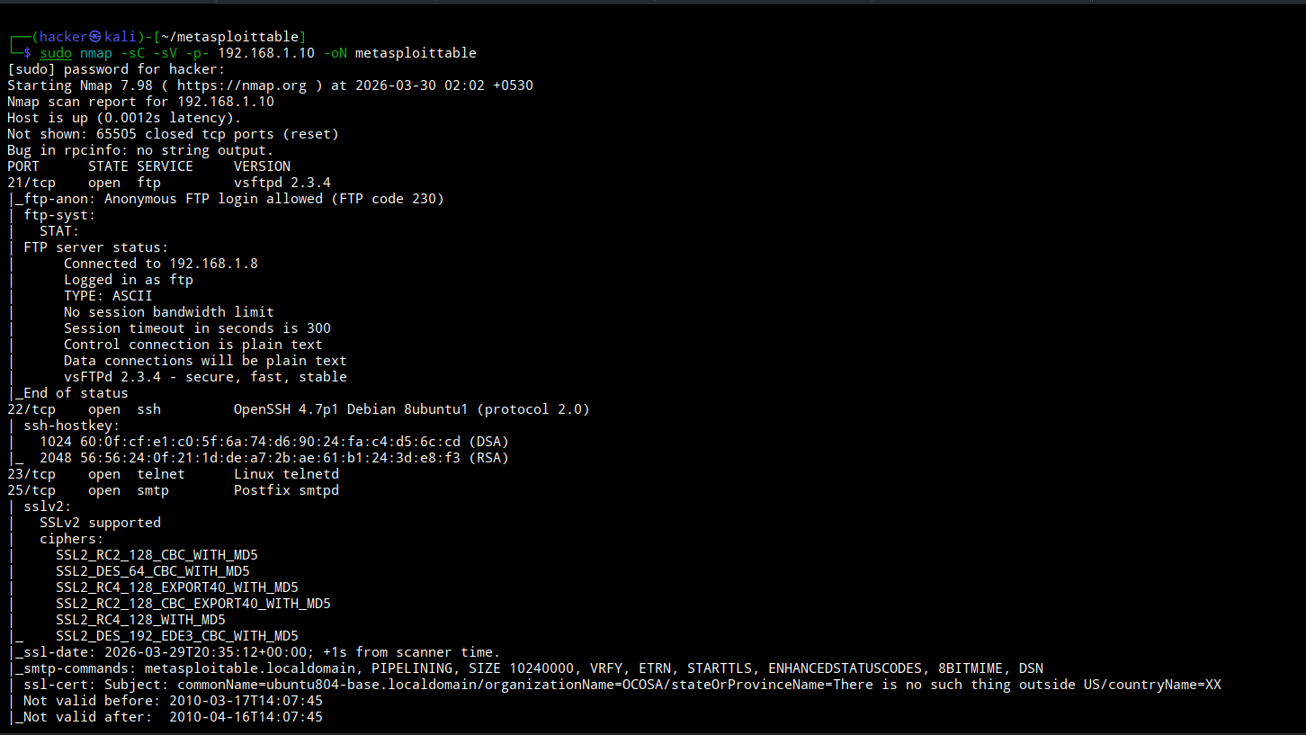

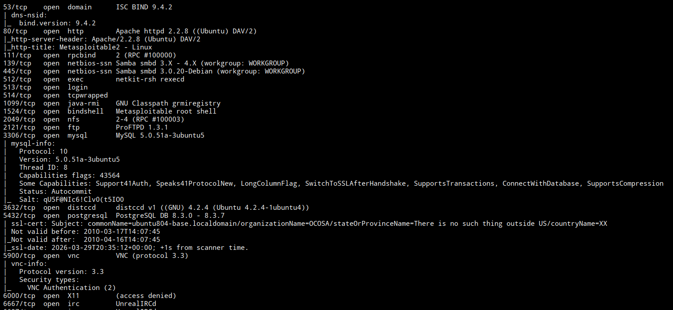
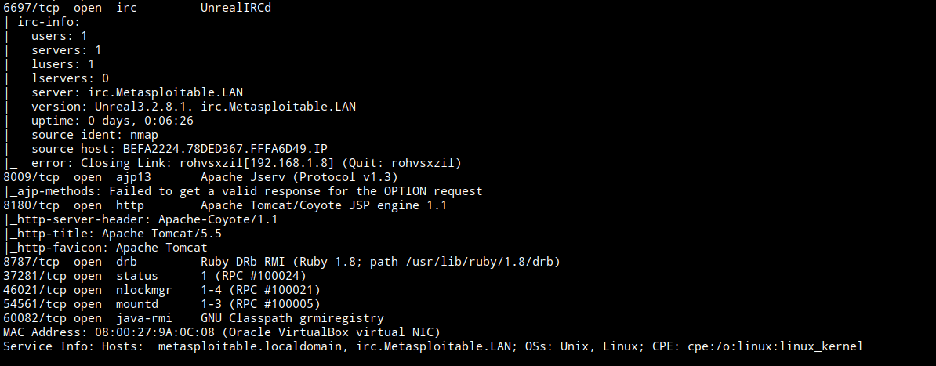
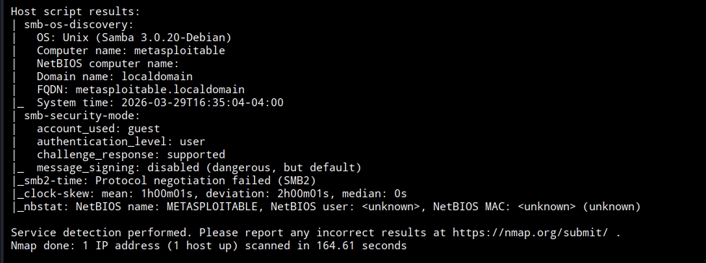

To verify whether the FTP service permits anonymous login without authentication.
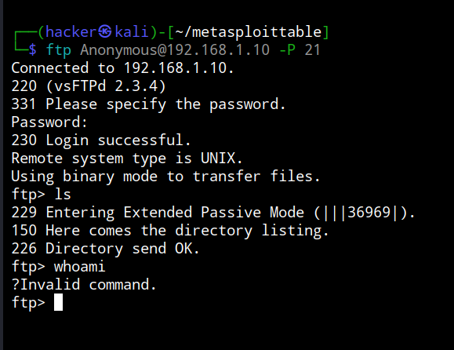
The FTP service is misconfigured, permitting anonymous login without requiring valid credentials. This misconfiguration may allow unauthorized users to access sensitive data.
Further analysis should be conducted to identify publicly known vulnerabilities and CVEs associated with the detected service version.
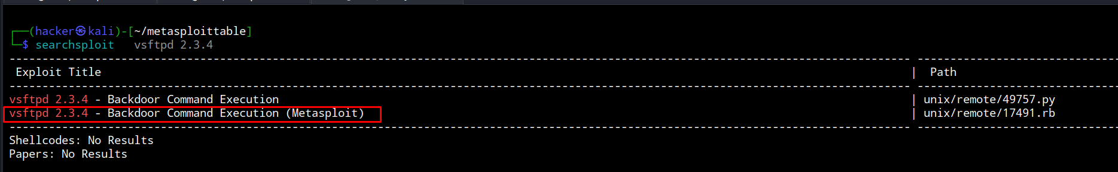
After exploiting the vsftpd 2.3.4 backdoor vulnerability using the Metasploit module exploit/unix/ftp/vsftpd_234_backdoor, a shell was successfully obtained on the target system.

Proof of Concept
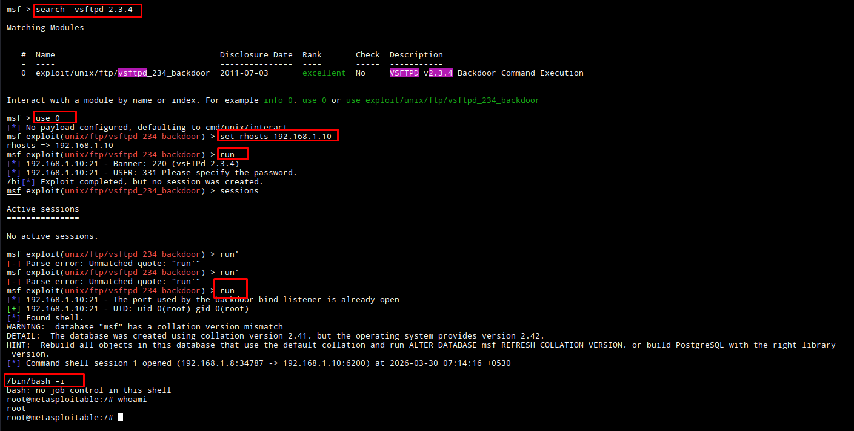
Vulnerability Exploited: OpenSSH Username Enumeration
Target System: 192.168.1.10
Vulnerability Explanation:
The SSH service is running an outdated version (OpenSSH 4.7p1), which is vulnerable to username enumeration. This allows attackers to identify valid users on the system.
Username enumeration techniques were identified, but no direct shell access was obtained.
Privilege Escalation:
In this lab environment, the exploited service provided direct shell access. Further enumeration allowed access to sensitive system information, demonstrating a high level of compromise.
Severity: Medium
Information Gathering
A full Nmap scan was performed to identify open ports and services on the target system. The results revealed multiple vulnerable services, which were further analyzed and exploited during this phase.

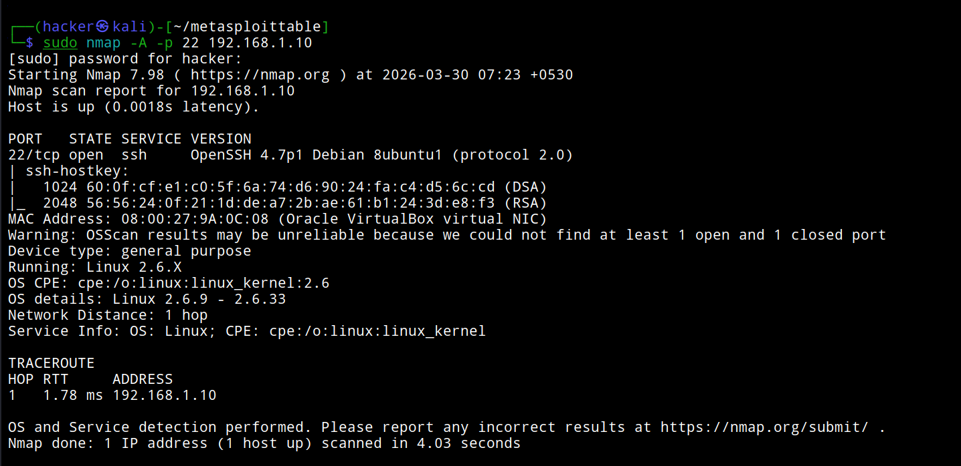

Proof Of Concept
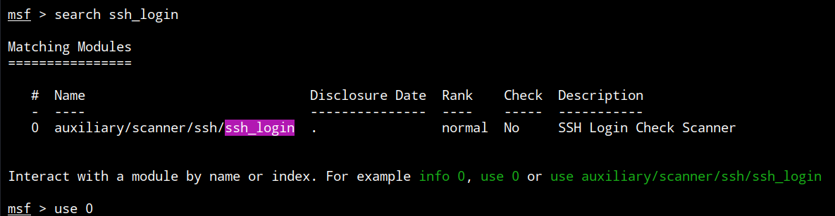
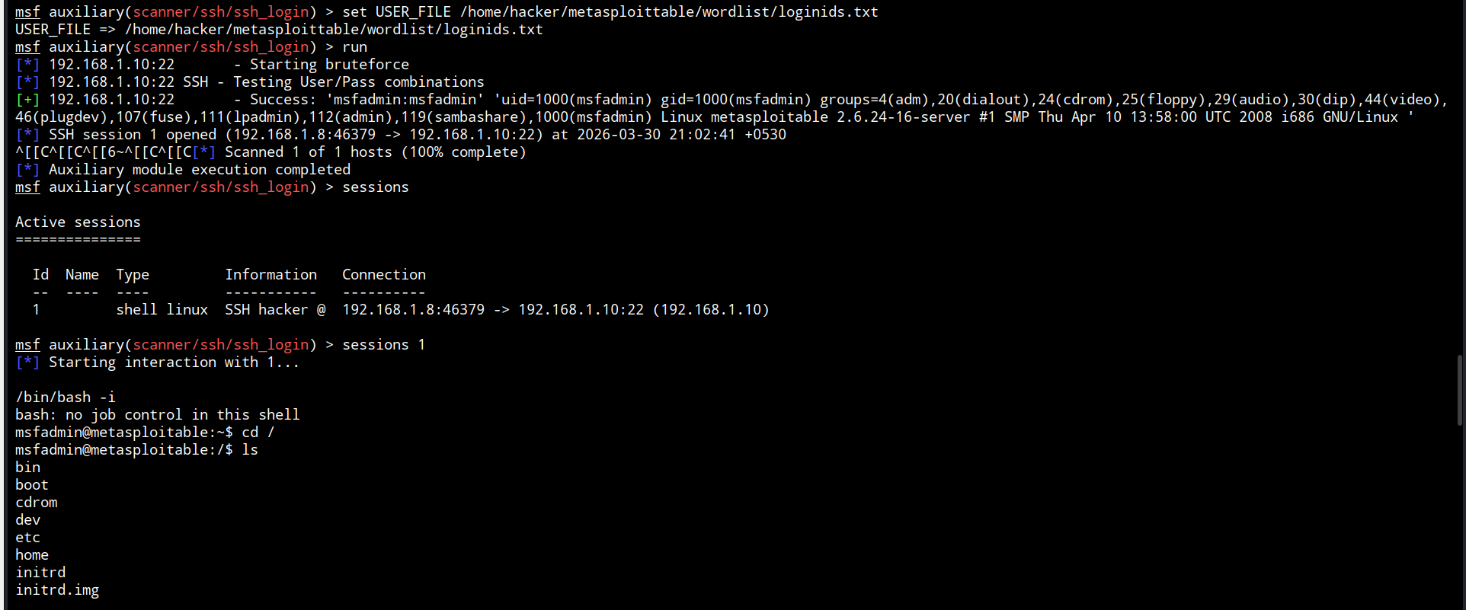
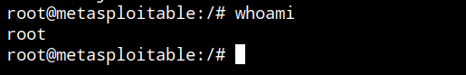
Additional Attachment
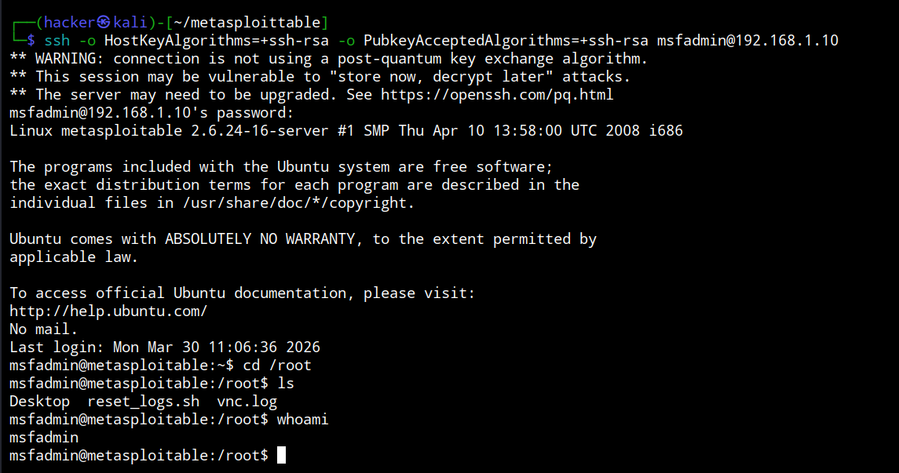

Vulnerability Exploited: Telnet Brute Force Attack
Target System: 192.168.1.10
Vulnerability Explanation
The Telnet service (port 23) allows remote login but lacks strong authentication controls.
This makes it vulnerable to brute force attacks, where attackers try multiple username-password combinations to gain access.
Exploitation
The Telnet service running on the target system was exploited using a brute force attack. An automated tool such as Hydra was used to perform multiple login attempts by testing a list of common passwords against a known username.
hydra -vV -t 4 -L /home/hacker/metasploittable/wordlist/loginids.txt -P /home/hacker/metasploittable/wordlist/password.txt 192.168.1.10 telnet
During this process, weak/default credentials were successfully identified. Using these valid credentials, a connection was established to the target system via the Telnet service:
telnet 192.168.1.10
After successful authentication, direct shell access to the system was obtained, confirming that the service was vulnerable to brute force attacks and lacked proper authentication security controls.
Privilege Escalation
After login, system enumeration revealed sensitive data and allowed privilege escalation, leading to full system compromise (lab environment).

Severity: HIGH
Information Gathering
During the initial phase of the assessment, a comprehensive scan of the target system (192.168.1.10) was conducted to identify open ports and running services. This was performed using Nmap, which helped in building a clear understanding of the system’s attack surface.
nmap -sC -sV -p- 192.168.1.10
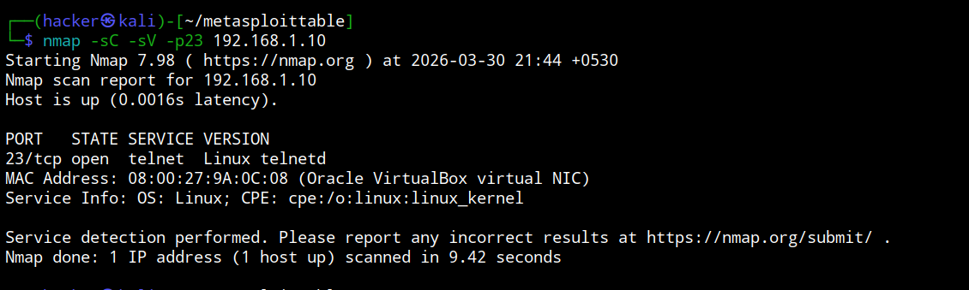

Proof of Concept
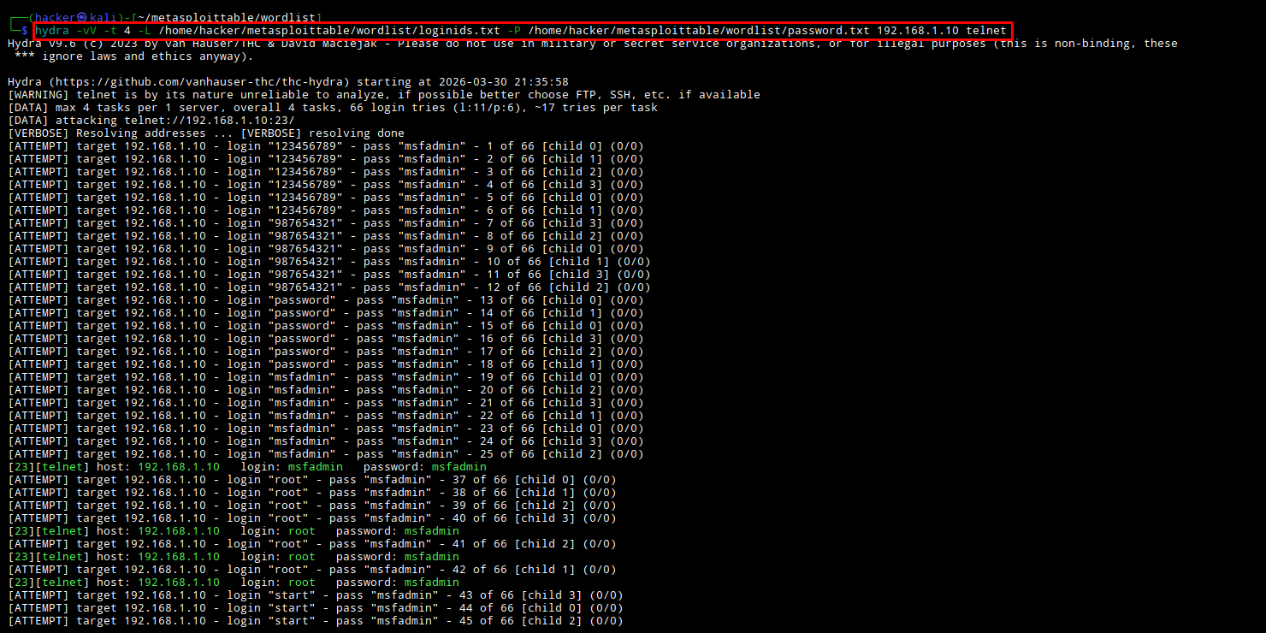

After successfully performing the brute force attack, valid credentials were obtained, which allowed unauthorized access to the system.

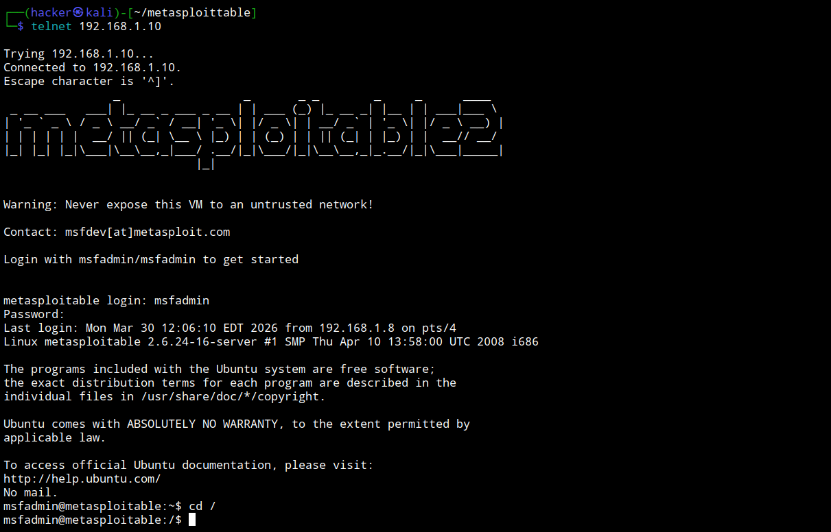
Vulnerability Exploited: SMTP Username Enumeration
Target System: 192.168.1.10
Vulnerability Explanation
The SMTP service running on the target system allows username enumeration through the VRFY command. This means an attacker can send specific requests to the SMTP server and check which usernames exist on the system based on the server’s response. Using this technique, multiple valid usernames were identified. However, this vulnerability alone does not provide direct shell access.
Privilege Escalation
In this lab environment, the enumerated usernames were used in further attacks, which helped in gaining deeper access to the system. Additional enumeration exposed sensitive system information, showing how this vulnerability can contribute to a larger compromise.
Severity: Medium
Information Gathering
A full Nmap scan was performed to identify open ports and services on the target system. The scan revealed that SMTP (Port 25) was open and misconfigured, allowing username enumeration. This service was further analyzed and exploited during this phase.
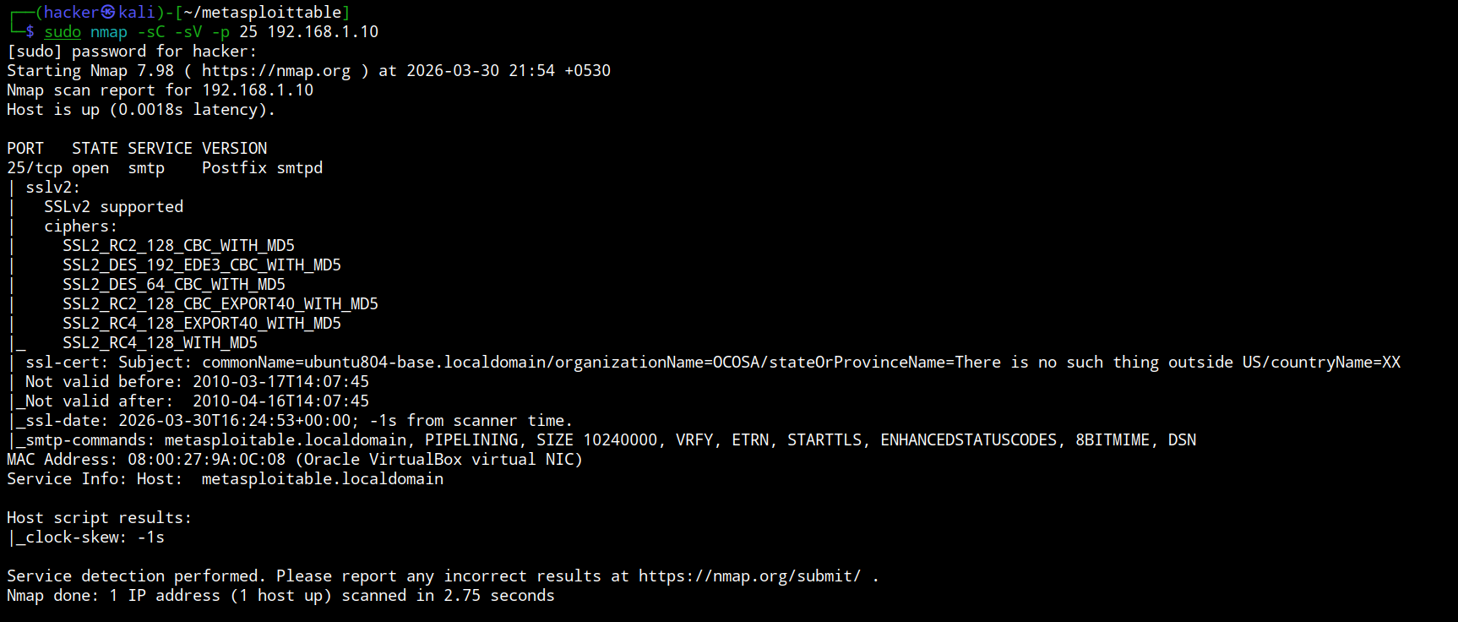

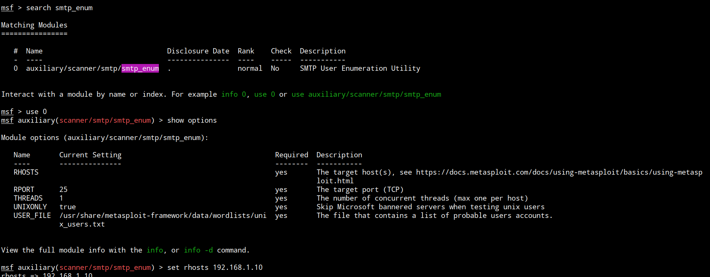
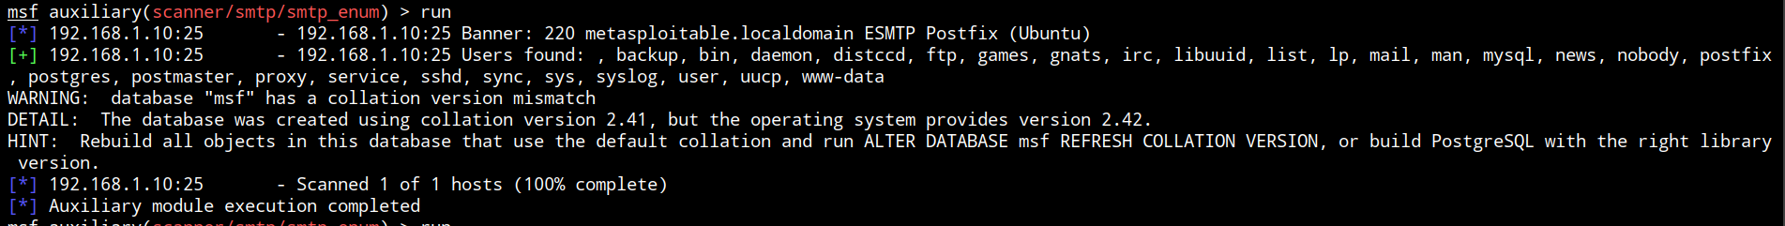
Proof of Concept
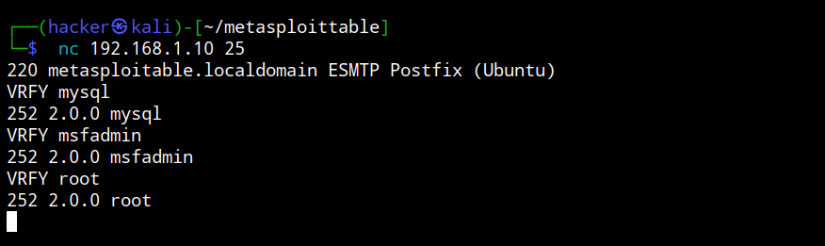
Vulnerability Exploited: WebDAV Misconfiguration (File Upload via HTTP)
Target System:192.168.1.10
Vulnerability Explanation
The web server running on Port 80 (HTTP) has WebDAV enabled and misconfigured, which allows unauthorized users to upload files to the server.
Using directory brute-forcing, a hidden directory /dav/ was discovered. This directory allowed file upload using WebDAV methods.
An attacker can exploit this vulnerability to upload malicious files (like a PHP reverse shell) and execute them on the server, potentially leading to full system compromise.
Methodology
Information Gathering
A directory brute-force scan was performed using DIRB:
dirb http://192.168.1.10
- The scan revealed a hidden directory:
/dav/
Exploitation using Cadaver
The cadaver tool was used to interact with the WebDAV service:
cadaver http://192.168.1.10/dav/
- Initially, uploading a file failed due to restrictions:
php-reverse-shell.php → 403 Forbidden
- Then another file was uploaded successfully:
shell.php → Upload succeeded
Exploitation Insight
- The uploaded PHP file can be accessed via browser:
http://192.168.1.10/dav/shell.php
This can lead to:
Remote Code Execution (RCE)
Reverse shell access
Full system compromise
Privilege Escalation
After gaining initial access through the uploaded shell, further enumeration can be performed to:
Access sensitive files
Escalate privileges
Gain full control of the system
Severity: High
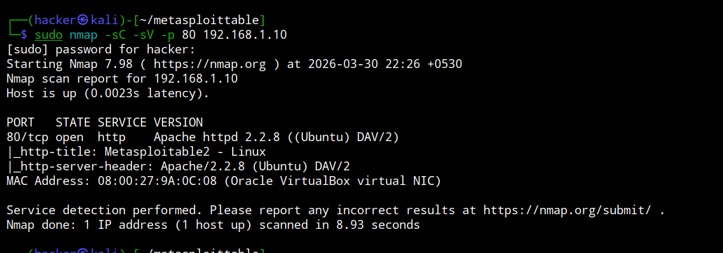
Proof of Concept
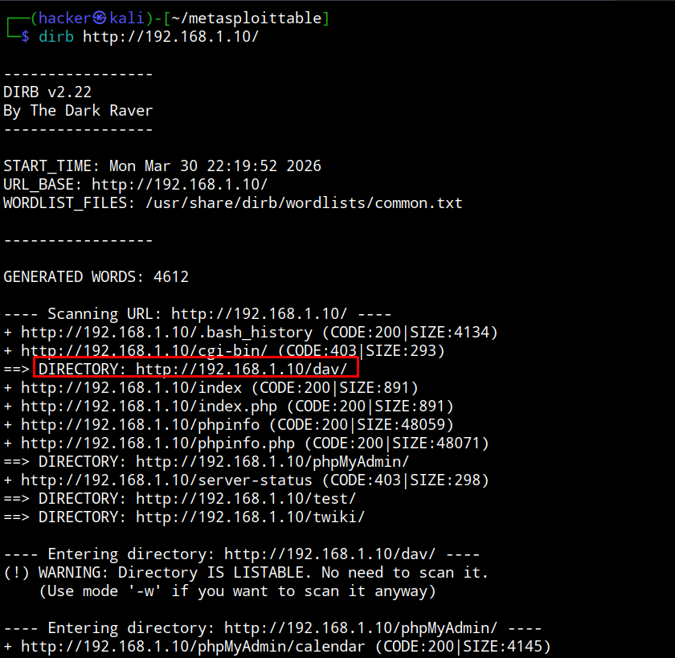
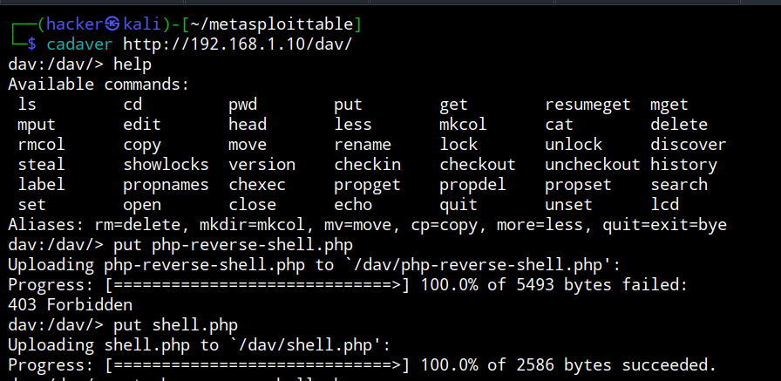

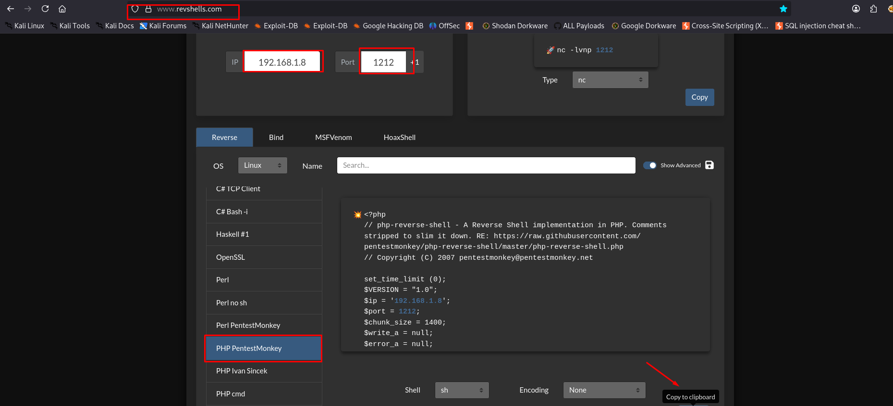

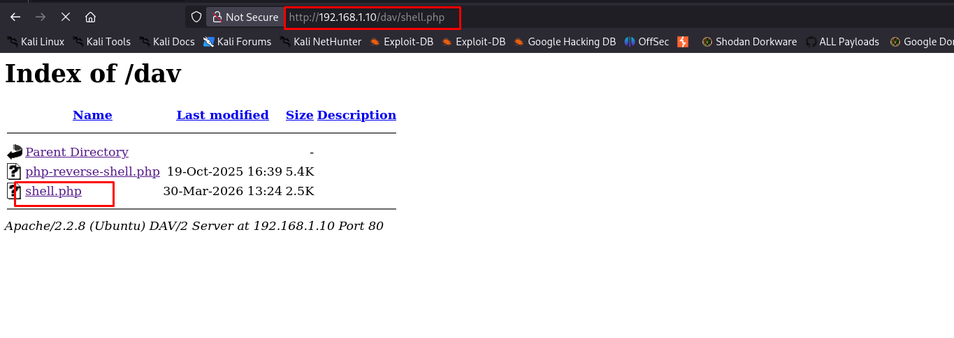
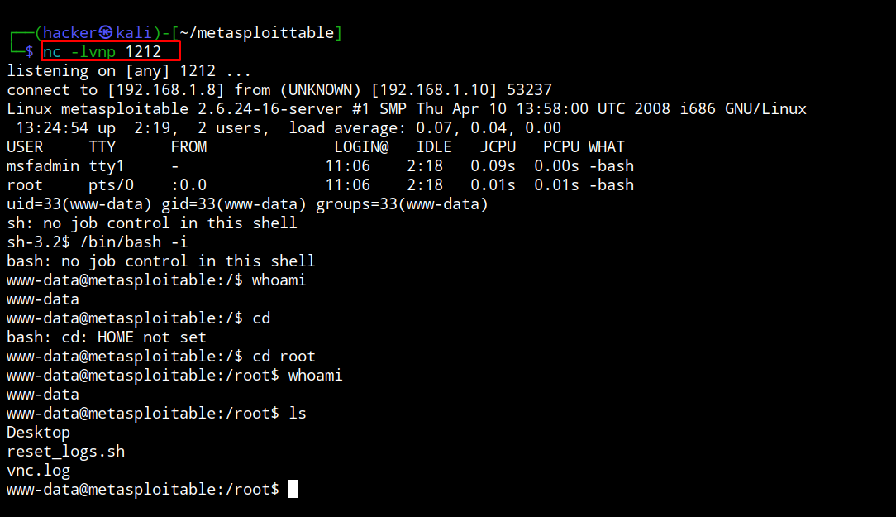
Vulnerability Exploited: Samba usermap_script Remote Code Execution
Target System: 192.168.1.10
Vulnerability Explanation
The target system is running a vulnerable version of Samba, which is affected by the usermap script vulnerability.
This vulnerability allows an attacker to execute arbitrary commands on the target system without authentication.
By exploiting this flaw, an attacker can directly gain remote access to the system in the form of a shell.
Methodology Information Gathering
During the Nmap scan, Samba service (Port 139/445) was found running on the target system.
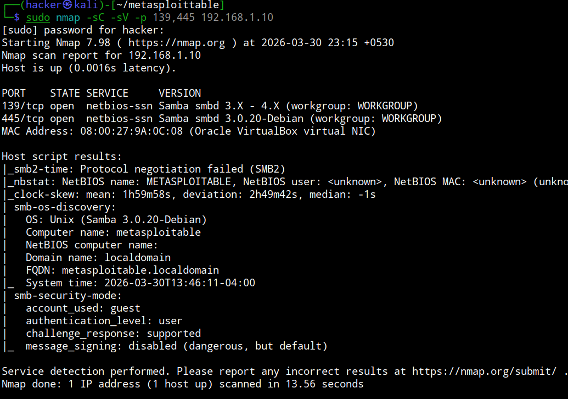
Further analysis confirmed that the Samba version is vulnerable to known exploits. Exploitation using Metasploit
The following Metasploit module was used to exploit the vulnerability:
use exploit/exit
multi/samba/usermap_script
set rhosts 192.168.1.10
run
Result
Reverse connection established:
Command shell session opened
Attacker successfully gained access to the target system

Shell Access
After exploitation, an interactive shell was obtained:
/bin/bash -i
This confirms successful remote code execution (RCE) on the target machine
Exploitation Insight
- No authentication required
- Direct command execution possible
- Full system access can be achieved easily
This makes it a highly critical vulnerability.
Privilege Escalation
- Initial shell access was obtained directly
- Further enumeration can lead to:
  - Root access
  - Sensitive data exposure
  - Full system compromise
Severity: Critical
Proof of Concept
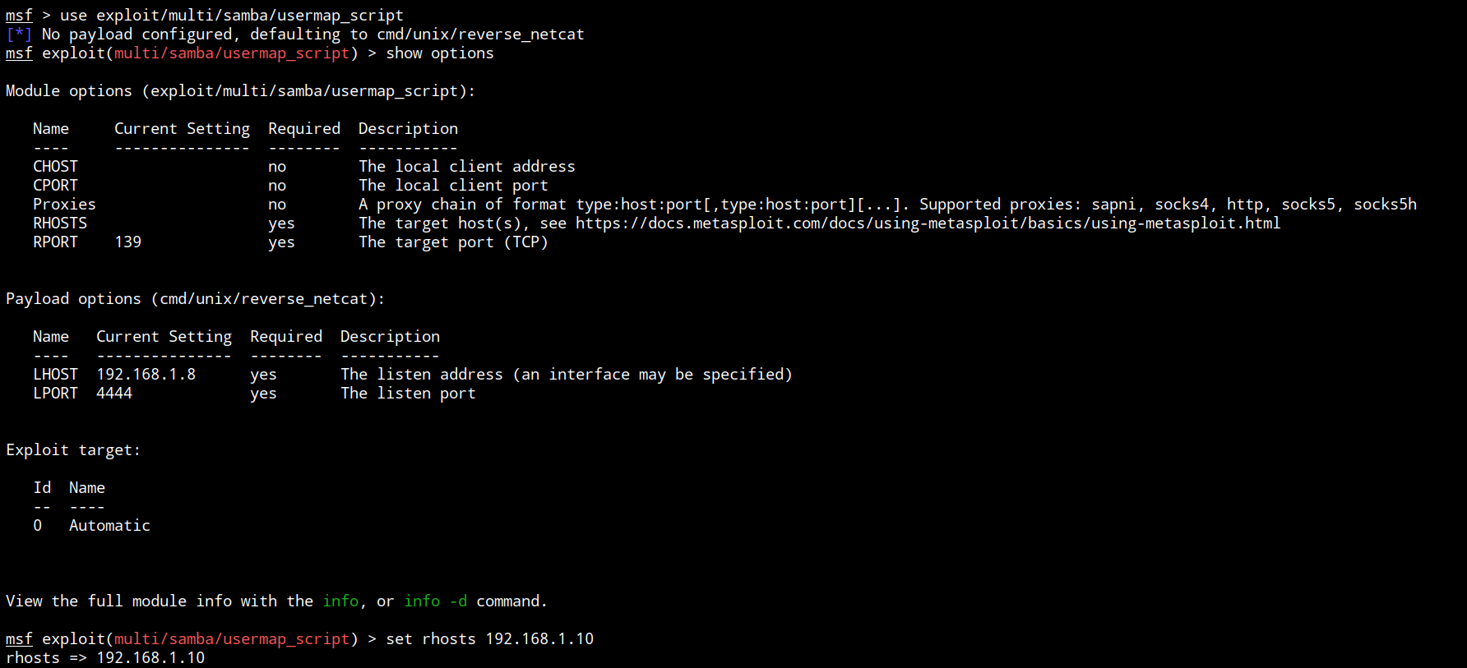
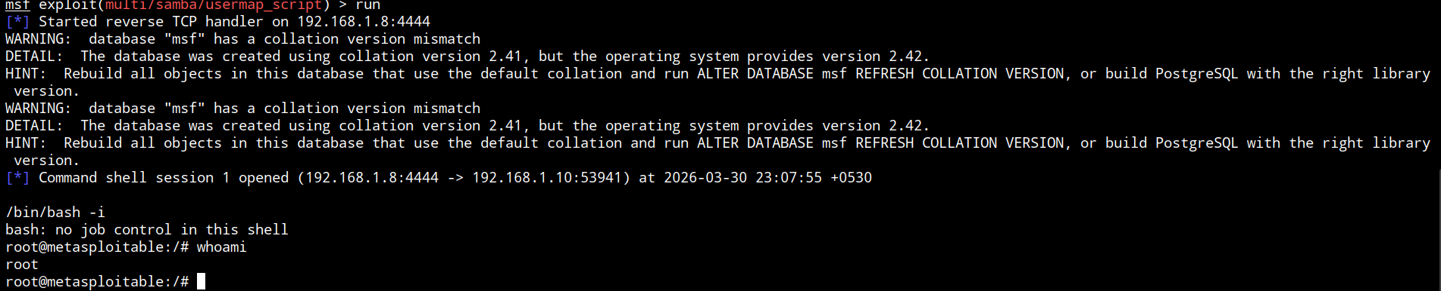

Vulnerability Exploited: Unauthenticated Remote Access via rlogin (Port 513)
Target System: 192.168.1.10
Vulnerability Explanation:
The target system is running the rlogin service on port 513, which is configured with trust-based authentication instead of secure credential verification.
The service relies on files such as .rhosts or /etc/hosts.equiv to determine trusted hosts. Due to improper configuration, the attacker’s machine is treated as a trusted host, allowing remote login without requiring a password.
This misconfiguration enables an attacker to gain direct shell access to the system without authentication. Since rlogin does not use encryption and depends on host-based trust, it is considered inherently insecure and deprecated in modern systems.
Information Gathering:
- Open ports identified: 512, 513, 514 (r-services)
- Service detected: rlogin running on port 513
- No authentication prompt observed during connection
- Successful remote access gained using:
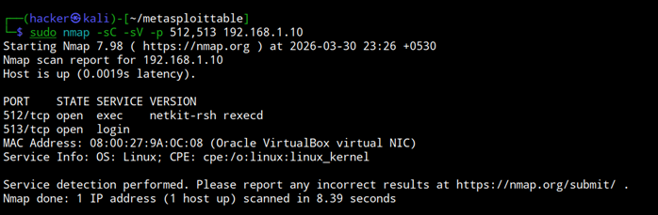
rlogin -l root 192.168.1.10
- Indicates presence of misconfigured trust relationships
Privilege Escalation: After successful login, the attacker may already obtain access as a privileged user (e.g., root) depending on configuration.
If not, the attacker can:
- Enumerate system information (whoami, id, uname -a)
- Check for SUID binaries
- Analyze cron jobs and writable files
- Exploit local privilege escalation vectors
This significantly increases the risk, as initial access can quickly lead to full system compromise.
Severity: Critical
Proof of Concept
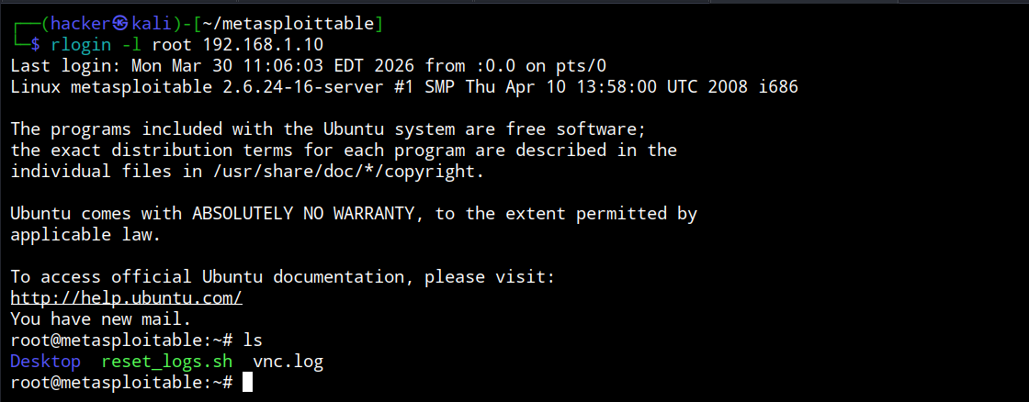
Vulnerability Exploited: Insecure Java RMI Service – Remote Code Execution (RCE)
Target System: 192.168.1.10
Vulnerability Explanation: The target system exposes a Java RMI (Remote Method Invocation) service on port 1099, which is vulnerable to remote code execution due to insecure configuration.
Java RMI allows remote communication between Java objects, but if improperly secured, it can allow attackers to:
- Load malicious classes remotely
- Execute arbitrary commands on the target system
In this case, the service does not enforce proper security restrictions such as:
- Authentication
- Codebase validation
- Security manager policies
As a result, an attacker can exploit this service using publicly available tools like Metasploit.
Information Gathering:
- Open port identified: 1099
- Service detected: Java RMI Registry
- Vulnerable to remote exploitation
- Exploit module used:
exploit/multi/misc/java_rmi_server
- Target configured:
set RHOSTS 192.168.1.10
run
- Result: Remote shell / Meterpreter session established
Exploitation:
The attacker used the Metasploit module to:
- Connect to the RMI registry
- Deliver a malicious payload
- Execute arbitrary commands remotely
This resulted in unauthorized remote access to the system.
Privilege Escalation:
Once access is obtained:
Attacker can enumerate system (whoami, id)
Identify privilege level
Exploit local vulnerabilities (SUID, cron jobs, kernel exploits)
Escalate to root access
Severity: Critical
Reason:
Remote Code Execution (RCE)
No authentication required
Full system compromise possible
Can lead to lateral movement in network
Remediation:
Disable unused Java RMI services
Apply latest security patches
Enforce authentication and access controls
Use Java Security Manager
Restrict access via firewall (block port 1099 if not needed)

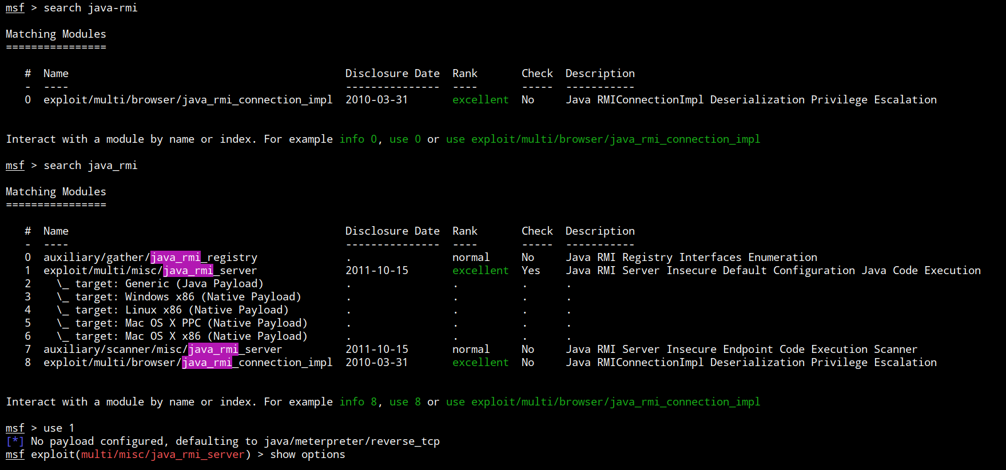
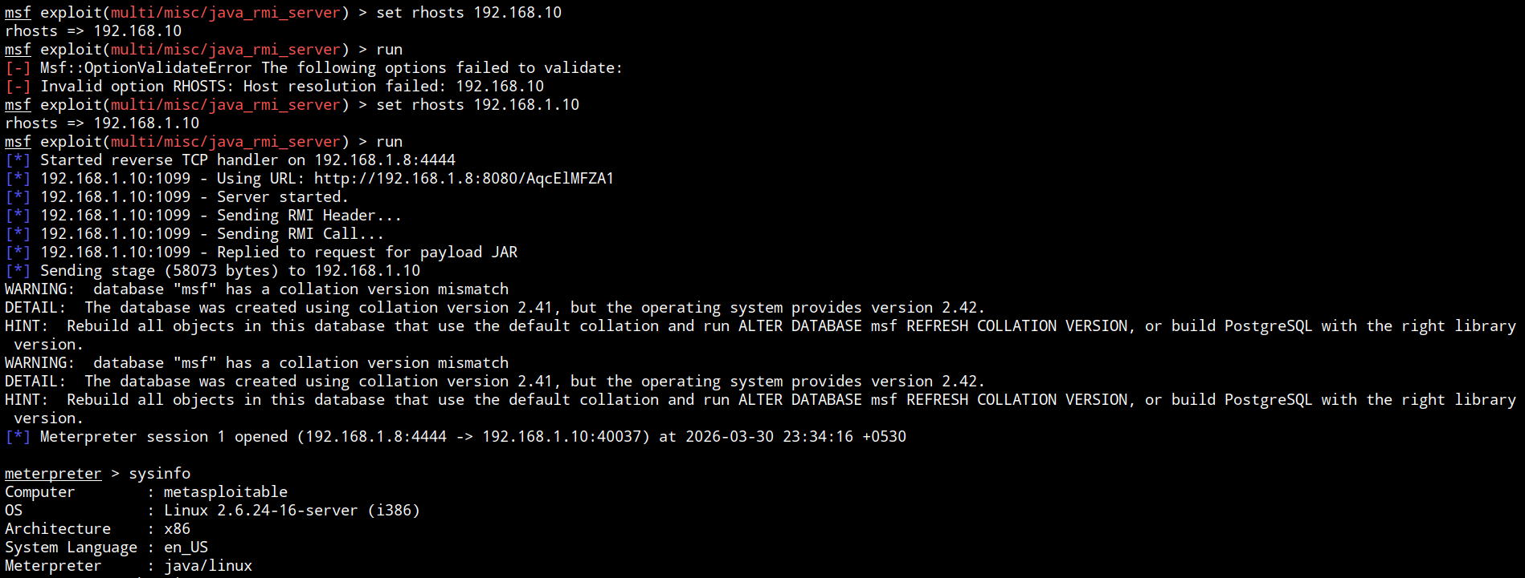
3.4 Report – House Cleaning
The house cleaning phase ensures that no traces of the penetration testing activities remain on the target system after the assessment is completed. This step is important to prevent any unintended security risks or system issues caused by leftover tools, accounts, or configurations.
After successfully completing the testing objectives on the lab system, all temporary changes made during the assessment were carefully removed. This included terminating active sessions, removing any created user accounts (if applicable), and ensuring that no backdoors or testing artifacts were left behind.
This process ensures that the system is returned to its original state and that no additional cleanup is required from the system owner.

4.0 Conclusion
The penetration test successfully demonstrated that the Metasploitable2 system contains multiple critical vulnerabilities that can be easily exploited by an attacker. Using the Metasploit Framework, unauthorized access was gained, and in some cases, full system control was achieved.
The assessment highlights that outdated services and insecure configurations significantly increase the risk of compromise. These vulnerabilities can lead to unauthorized access, data exposure, and complete system takeover if not addressed properly.
To improve the security posture of the system, it is essential to implement regular patching, secure configurations, and continuous monitoring. Proactive security measures will help in reducing the attack surface and protecting the system from potential threats.

This penetration testing was conducted in a controlled lab environment using Metasploitable2 for educational and security research purposes.

